When QCDE is installed, you will see that in the start menu there will be two shortcuts: Single player and Open QCDE Server browser (Doomseeker).

By default, there are no LAN servers, we must set one as a Pinned server.

Go to the menu and select options > then configure.

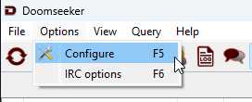

Select Pinned Servers, then hit Add, Type in the server IP address, and then hit ok.  
  
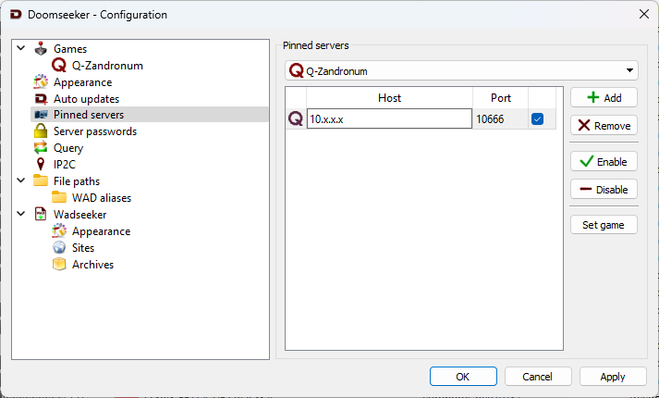

Hit ok and your pinned server should be on the top.

